The graph consists of nodes and relationships depicted by arrows

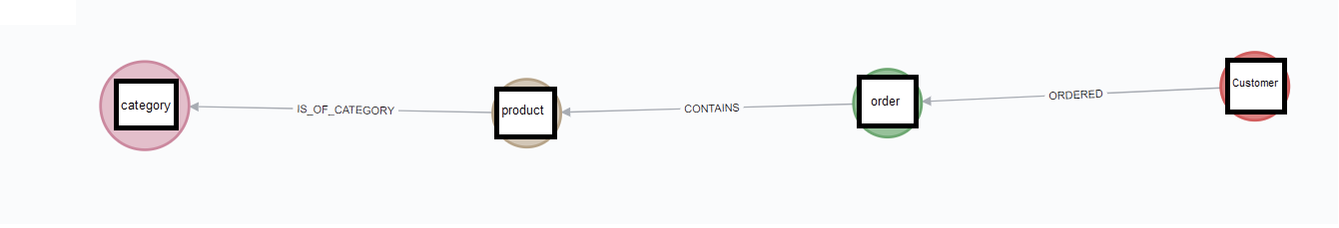

so, a customer can create an order which contains a product which is of a category, the relations are given by the arrows

The node-labels are:

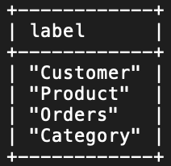

The relationships are given by

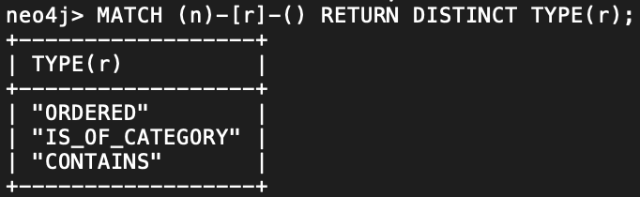

The relationships are connected to the following nodes

